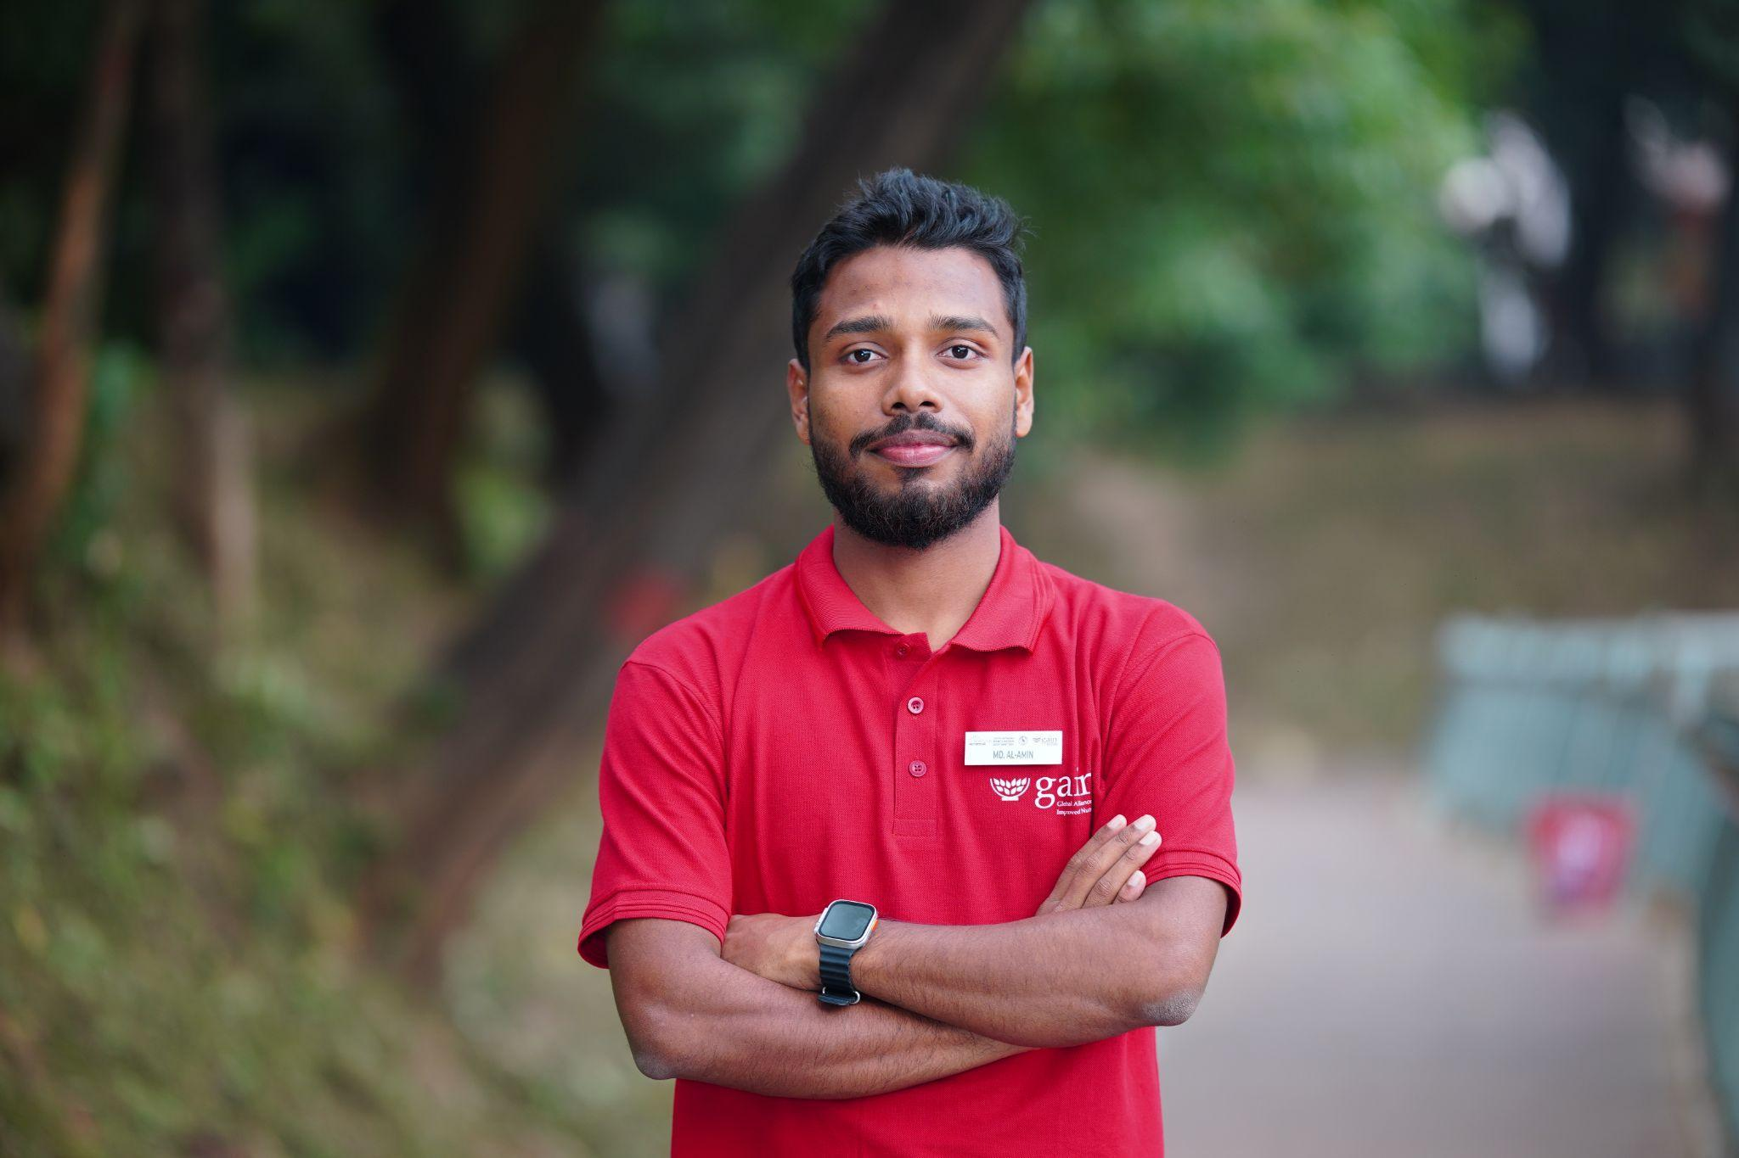
From Campus Conversations to Global Advocacy: Al-Amin’s Journey in Transforming Food Systems

In December 2024, Md. Al-Amin joined a Training of Trainers programme organized by the Global Alliance for Improved Nutrition and the SUN Youth Network Bangladesh, with support from the Ministry of Health and Family Welfare and the Food Planning and Monitoring Unit. The four day training brought together twenty five young participants eager to learn how to strengthen local food systems. For Al-Amin, it became an important starting point for the work he would soon lead.

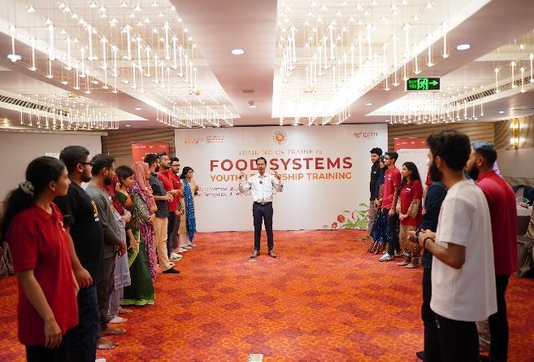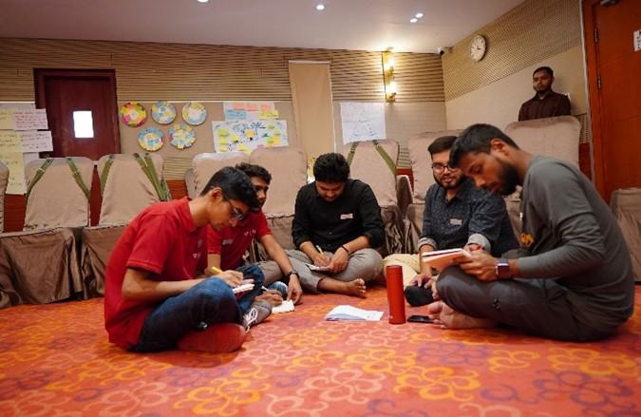
“The ToT was incredibly empowering. We gained practical tools to analyze local food systems, identify gaps and mobilize peers. I felt a responsibility to take these lessons back to my university and encourage action where I studied,” he said.
Back on campus, Al-Amin began by observing daily habits and speaking with students. He asked about their eating patterns, their understanding of food sources and their awareness of food waste in canteens. From these conversations, one issue stood out. Many students had limited understanding of sustainable choices, nutrition or the environmental impact of food waste.
“I noticed a disconnect,” he explained. “Students could access a range of foods, yet many were unsure about how to make nutritious selections or why food waste matters. It showed me that peer-led initiatives could help build a more informed food culture on campus.”
Guided by this insight, Al-Amin launched a series of youth focused discussions and workshops at his university. These sessions introduced students to the basics of sustainable food systems, the value of dietary diversity and small ways to reduce waste in their everyday routines.
Inspired by the response, he expanded his efforts and facilitated a three day Food Systems Youth Leadership training at the Dhaka University of Engineering and Technology. He adapted the ToT model to support engineering students in building practical advocacy skills and identifying opportunities for food system improvements within their own environment.

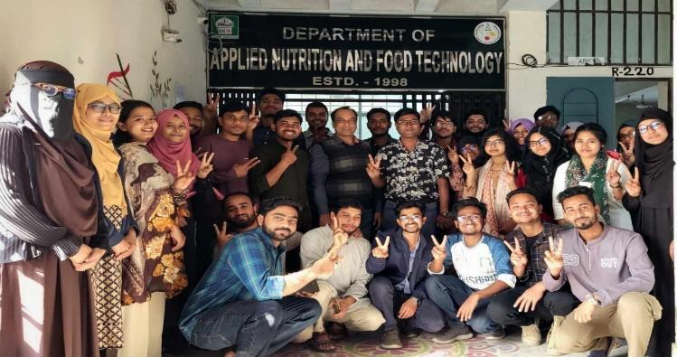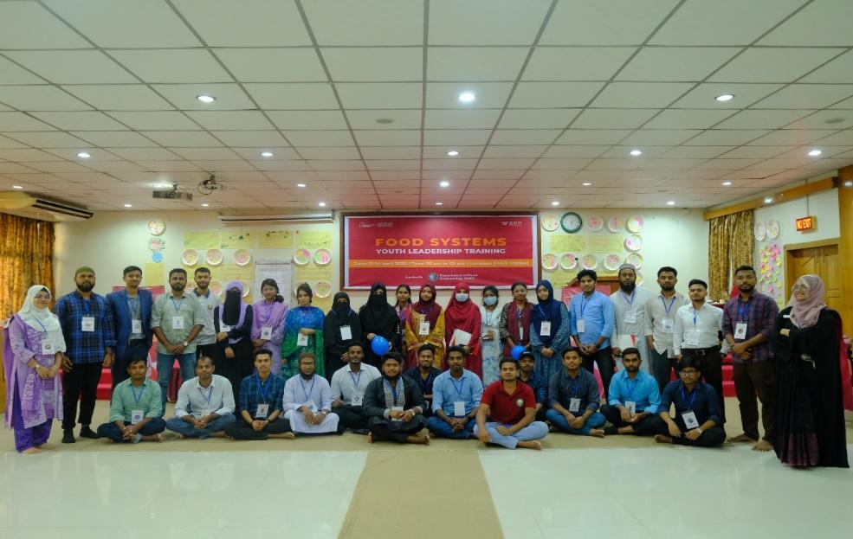
The impact became visible through the actions of the participants. Fatima, an engineering student who joined the training, said, “Al-Amin’s sessions at DUET made the topic meaningful for us. Our group started a campaign to reduce food waste in the cafeteria, and we can already see the difference.”
In early 2025, while working with GAIN Bangladesh, Al-Amin applied to the Act4Food initiative supported by GAIN. After multiple stages of assessment, including a viva voce, he was selected as Bangladesh’s national youth representative. He attended the Act4Food capacity building workshop in Arusha, Tanzania, joining young leaders from more than twenty countries.
Through field visits and group work in Tanzania, Al-Amin strengthened his understanding of community based solutions and returned to Bangladesh with new ideas to support the youth he mentored. The groups he trained have since launched awareness campaigns, food related community projects and youth led activities that reflect shared learning and collective purpose.

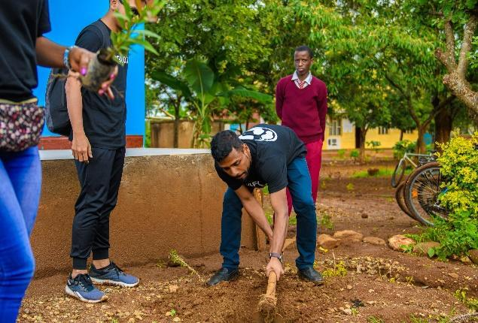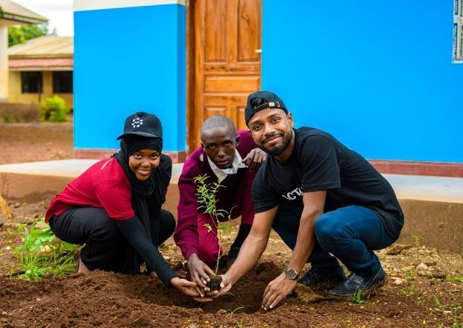

At present, Al-Amin is working on a collective action project focused on reducing micronutrient deficiencies among adolescents by promoting nutrient rich local foods and revitalizing indigenous food systems. He is also exploring ways to engage with multinational companies, advocating for practices that are environmentally friendly and supportive of consumer wellbeing.
Al-Amin’s journey from a university student to a national and global youth advocate shows the value of investing in young leaders. With the right support and opportunities, they not only contribute to change but also guide it forward for others.

